CRUD operations using JSON

Example 1:

Creating the values:

|  |
| --- |
| PUT library/Examples/test1  {  "Title":"This is the first test example",  "Executed by":{  "first":"User1",  "last":"CTS"  },  "Executed date":"14th October 2016"  } |

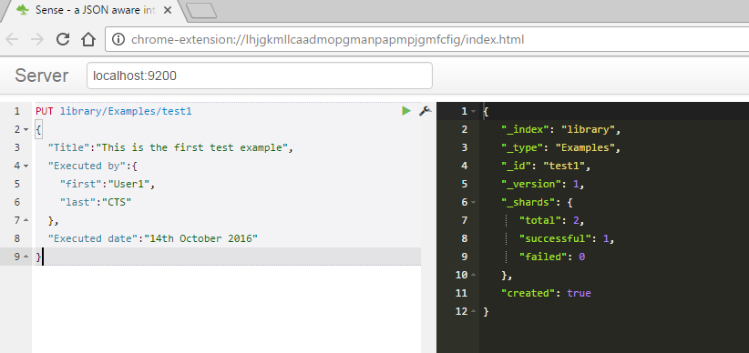

Example 2:

Fetching the values:

|  |
| --- |
| GET library/Examples/test1 |

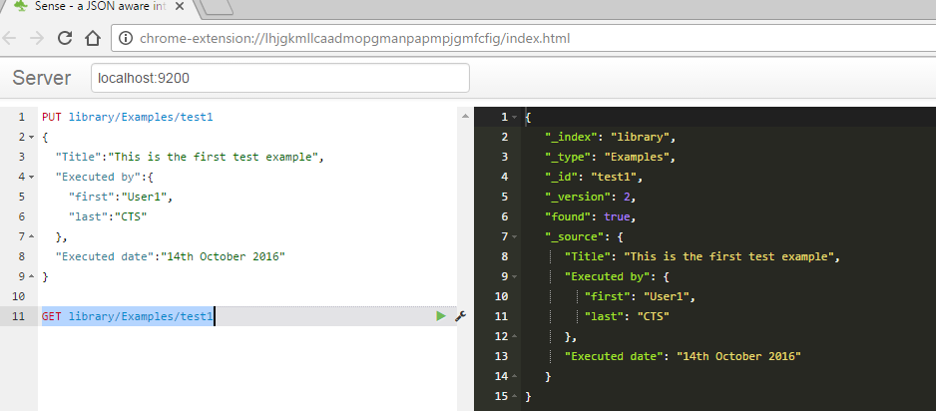

Example 3:

Updating a document/Overwriting a document

Note: A new field “**Result**” is added. When we try to update, the old record document gets overwritten with the new value. After executing, note the output console. The “Created” field is present with the value “false”. This points to the reason that the test1 is not created again since it is already present, and hence overwritten.

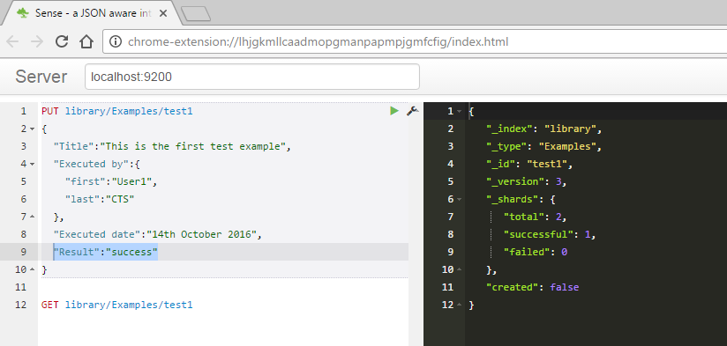

While retrieving the output will be as follows, with the value updated. Note the output console containing the “Result” filed added.

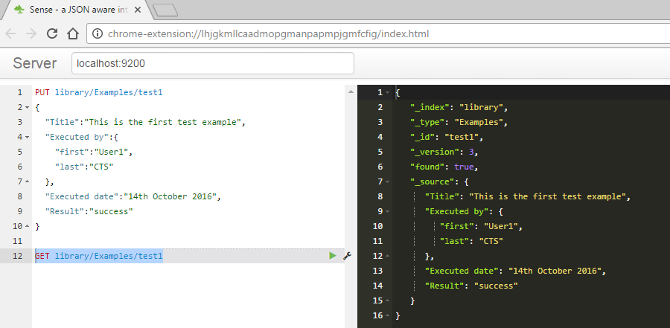

We can also use the Update API present. An example of that is as follows:

|  |
| --- |
| POST library/Examples/test2/_update  {  "doc":{  "Result":"success"  }  } |

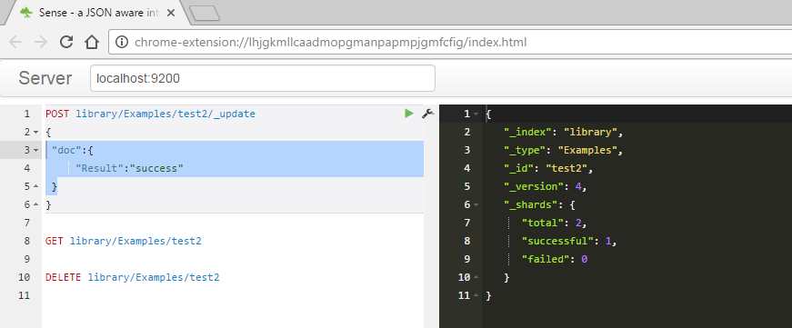

The output will be as follows.

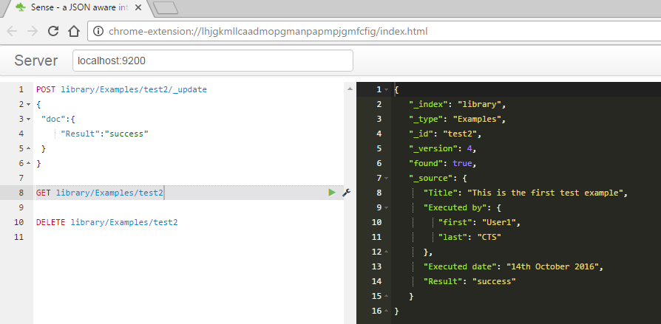

Example 4:

Deleting the document.

|  |
| --- |
| DELETE library/Examples/test2 |

Note: the status “successful” field present in the output console.

